**PROJECT TITLE**

**College Name: CHIKKANNA GOVERNMENT ART’S COLLEGE**

**College Code:** **06**

**TEAM ID:**

**TEAM MEMBERS:**

**Team LeaderName:** Indhumathi.M

**Email:** indhupooja71@gmail.com

**Team Member1:**Veeralakshmi.V

# Email: lakshmiveeralakshmi109@gmail.com

**Team Member2:**  Mohana.J

**Email:** mohanaj055@gmail.com

**Team Member3:** Sanjeevi.V

**Email:** sanjeevisanjeevi2528@gmail.com

# 1.INTRODUCTION

## 1.1 Project Overview

The Lease Management System is a Salesforce-based application designed to streamline the processes associated with leasing real estate properties. It handles tenant management, lease contracts, payments, and communication with automation features such as flows, approval processes, and email alerts.

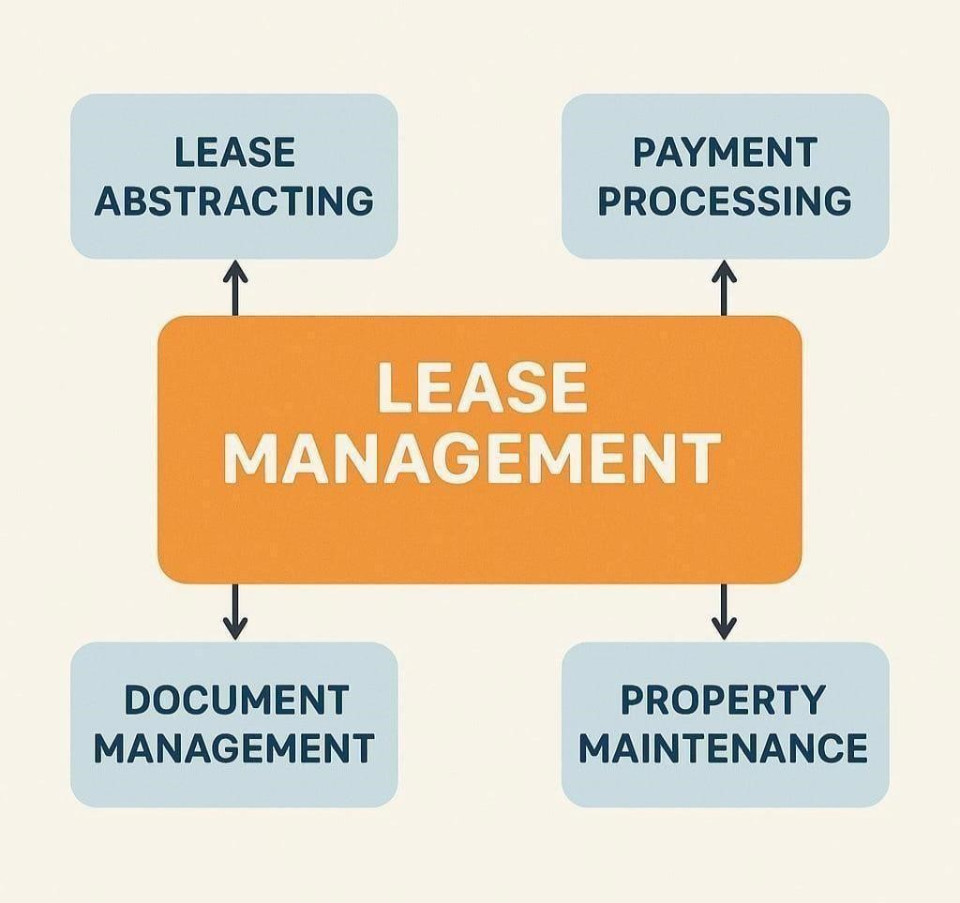

## 1.2 Purpose

The main objective of the project is to enable organizations to efficiently manage properties, tenants, and lease-related activities. It reduces manual intervention, improves accuracy, and ensures better compliance and communication.

# DEVELOPMENT PHASE

**Creating Developer Account:**

By using this URL [**- https://www.salesforce.com/form/developer-signup/?d=pb**](https://www.salesforce.com/form/developer-signup/?d=pb)

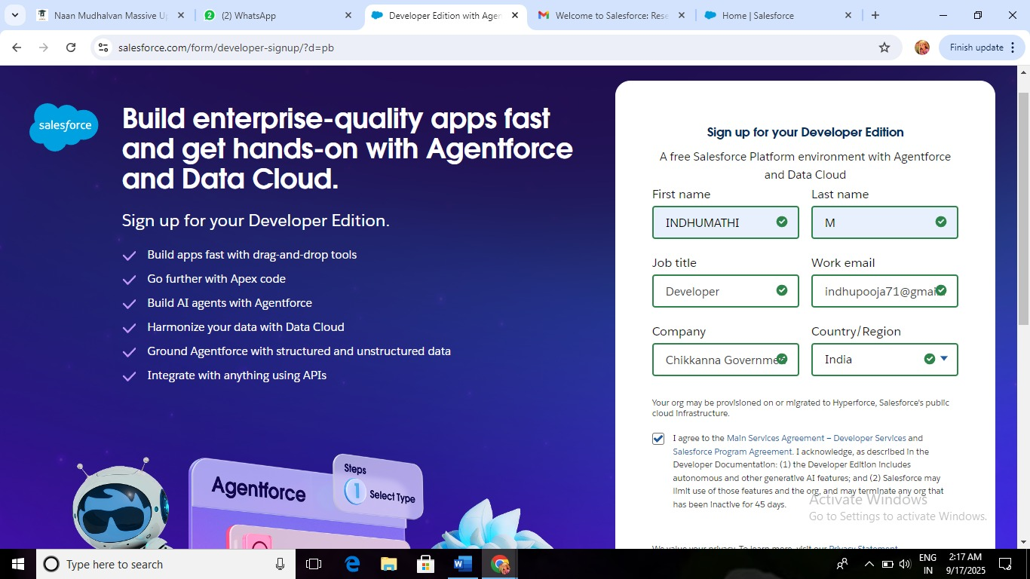

* Created objects: Property, Tenant, Lease, Payment

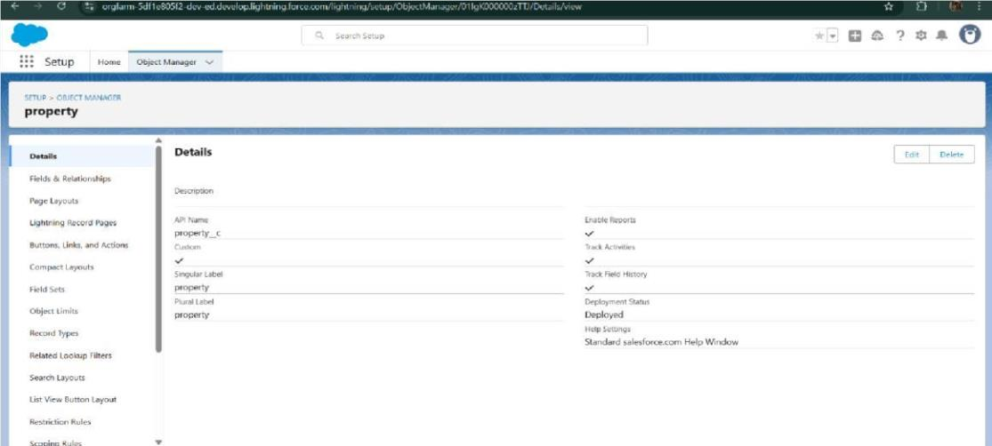

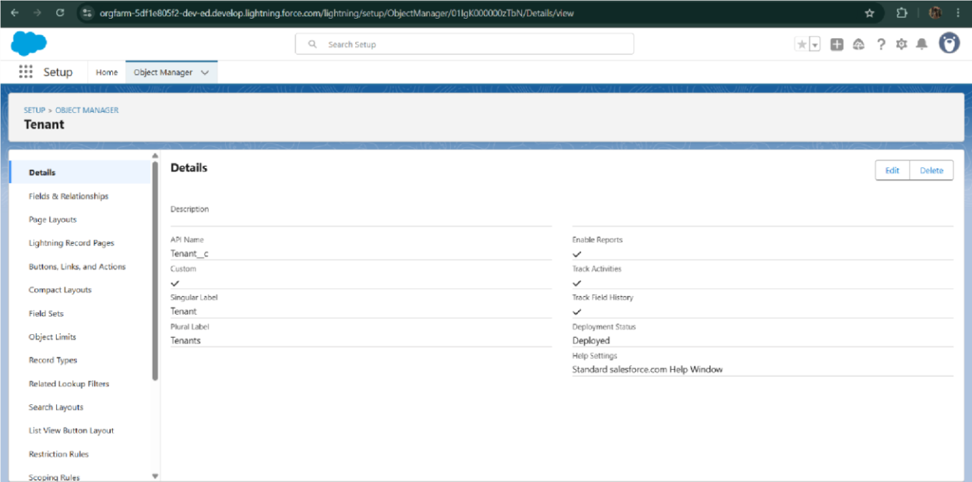

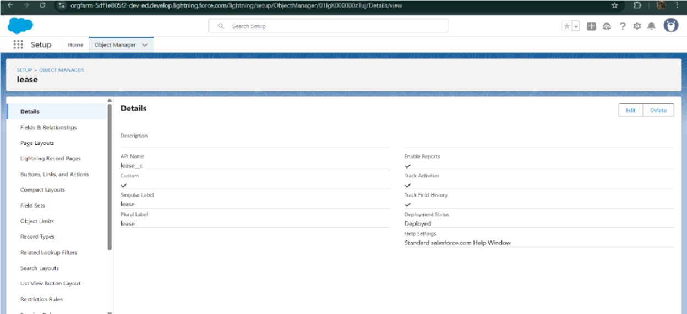

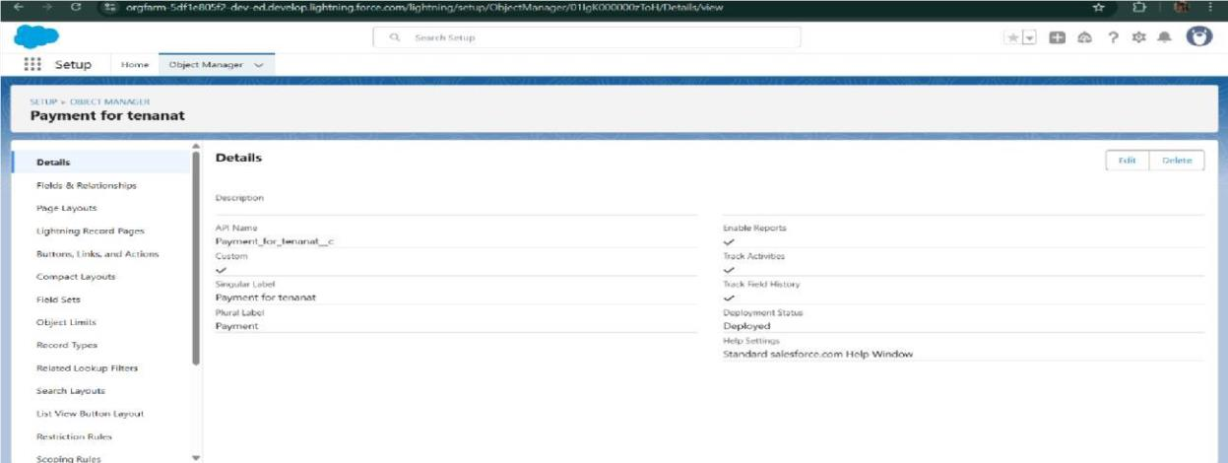

* Configured fields and relationships

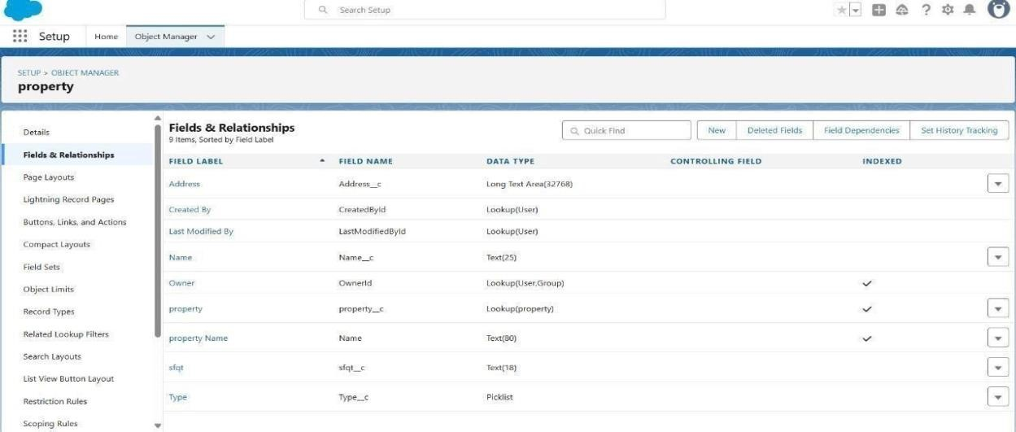

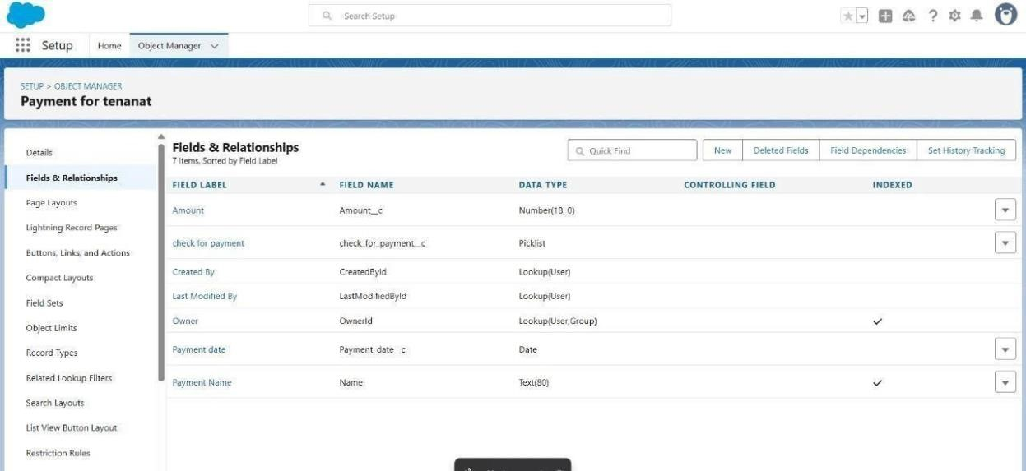

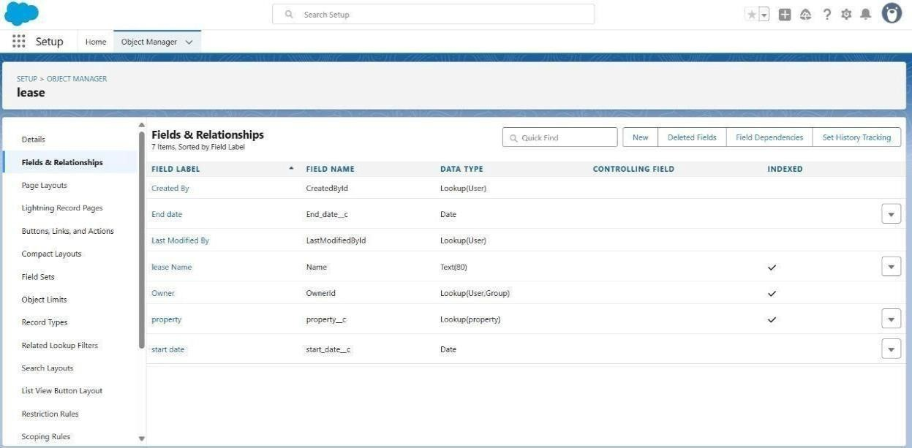

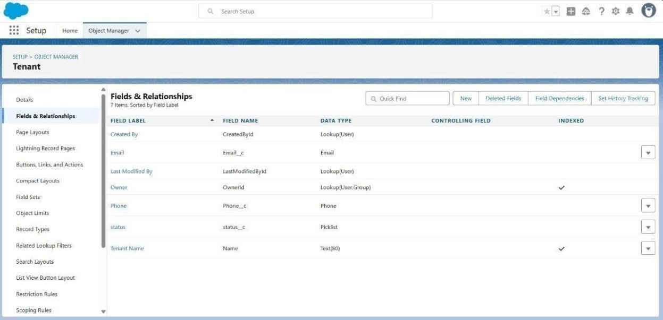

* Developed Lightning App with relevant tabs

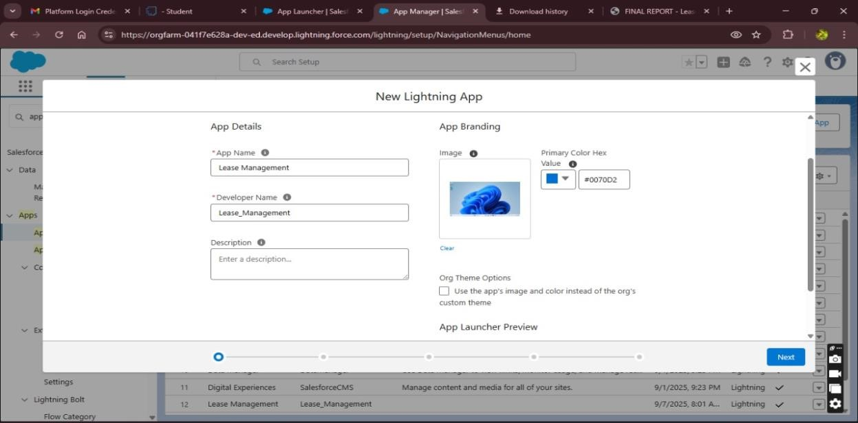

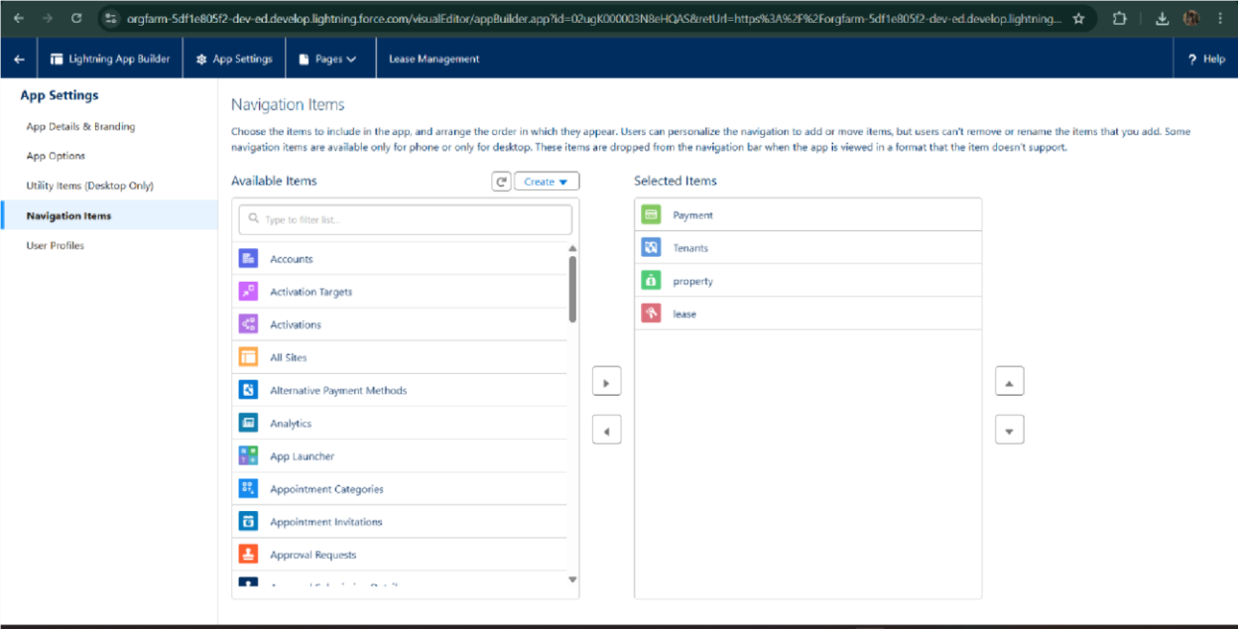

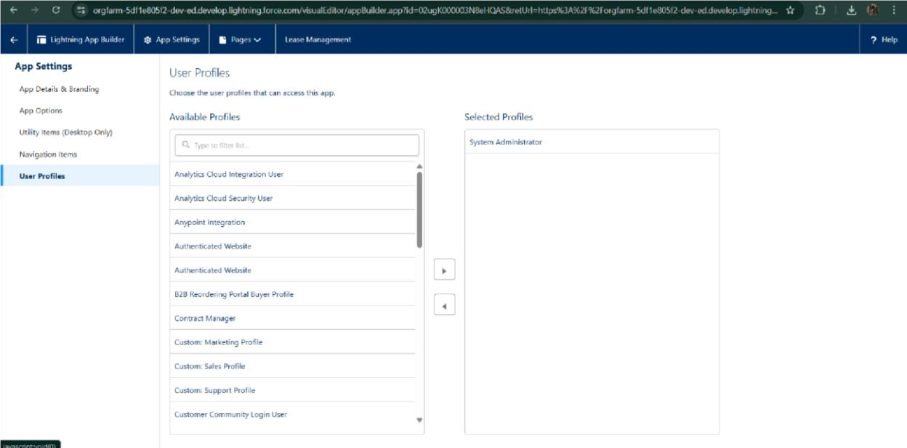

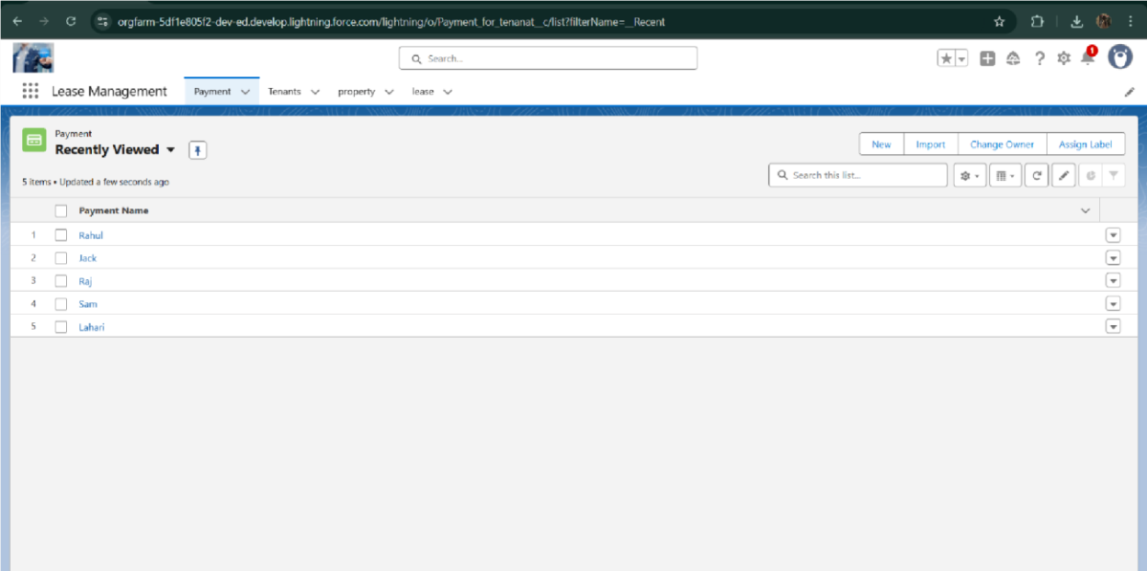

* Implemented Flows for monthly rent and payment success

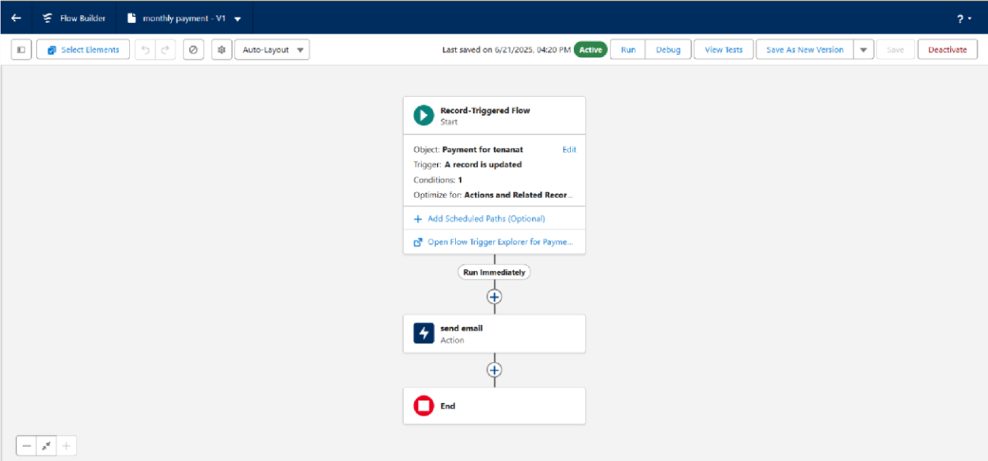

* To create a validation rule to a Lease Object

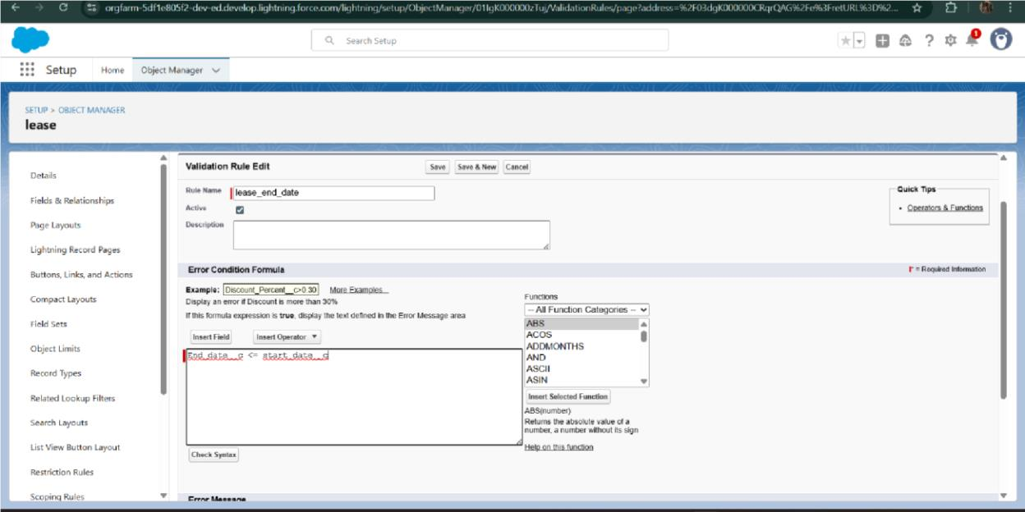

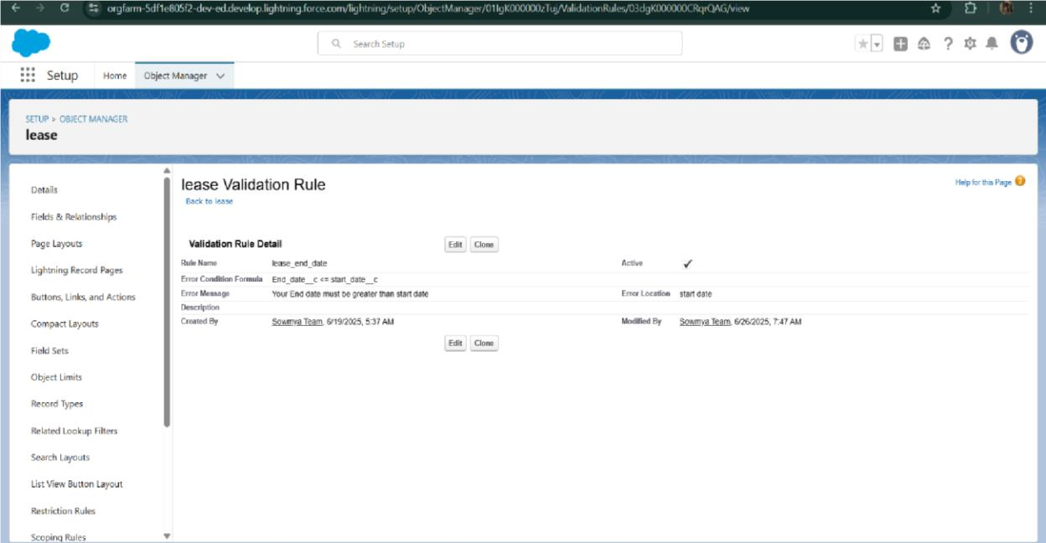

* Added Apex trigger to restrict multiple tenants per property

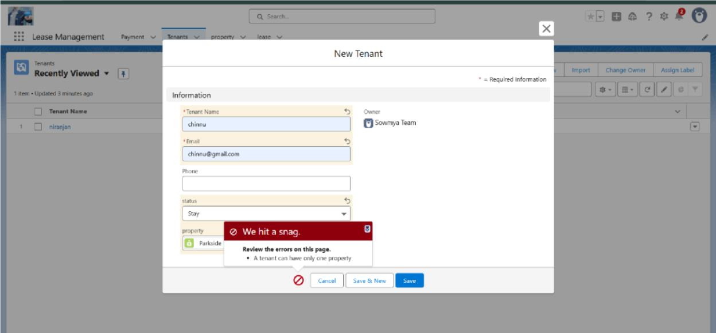

* Scheduled monthly reminder emails using Apex class

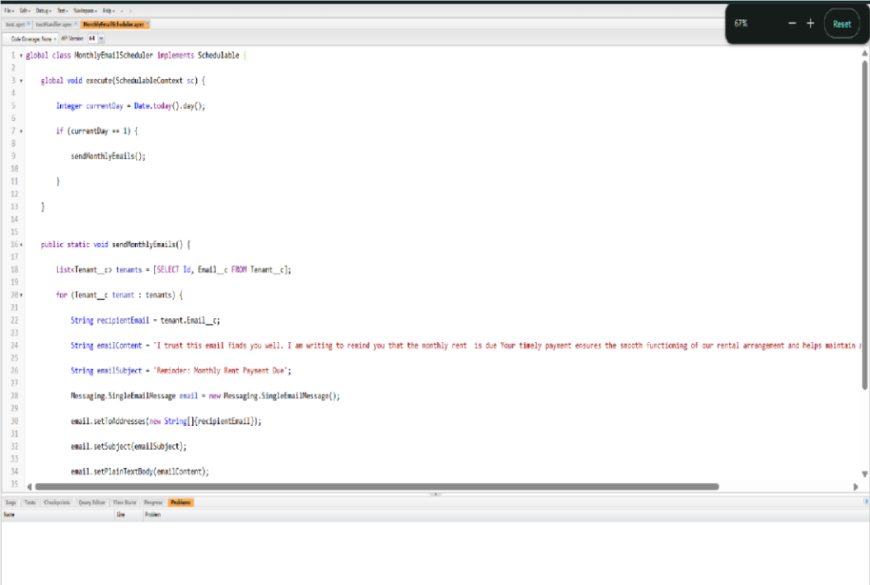

* Built and tested email templates for leave request, approval, rejection, payment, and reminders

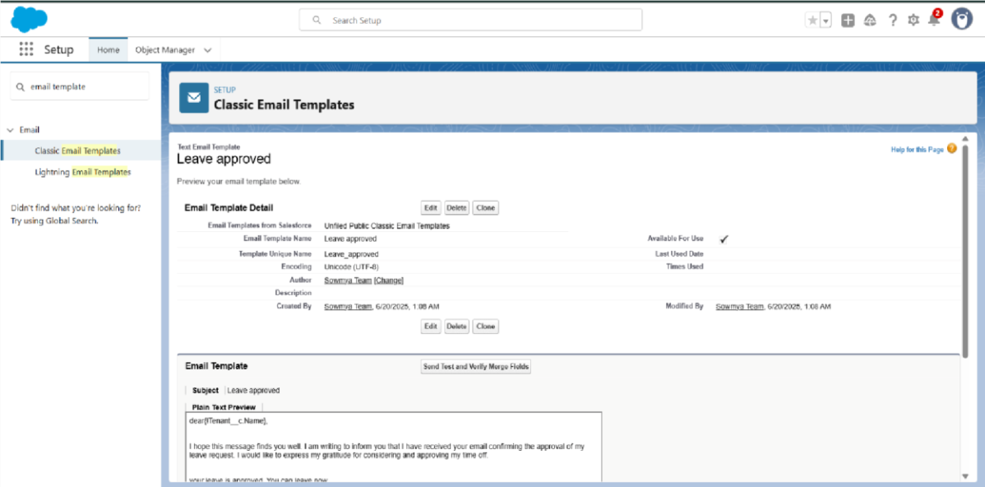

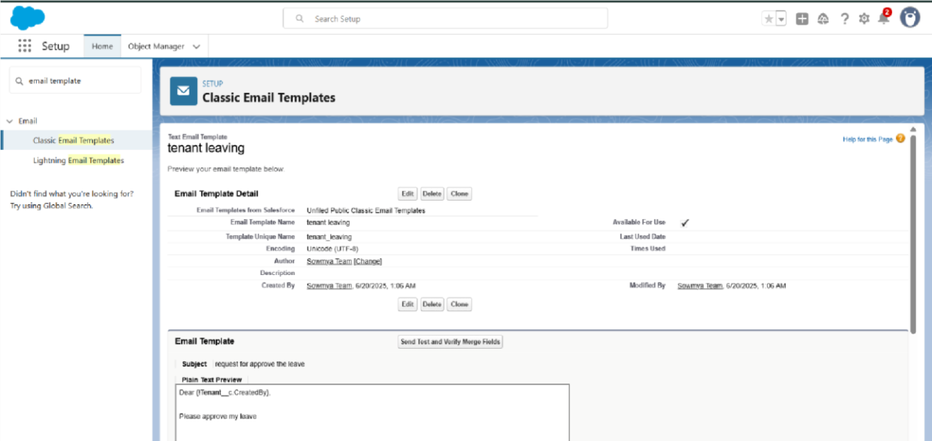

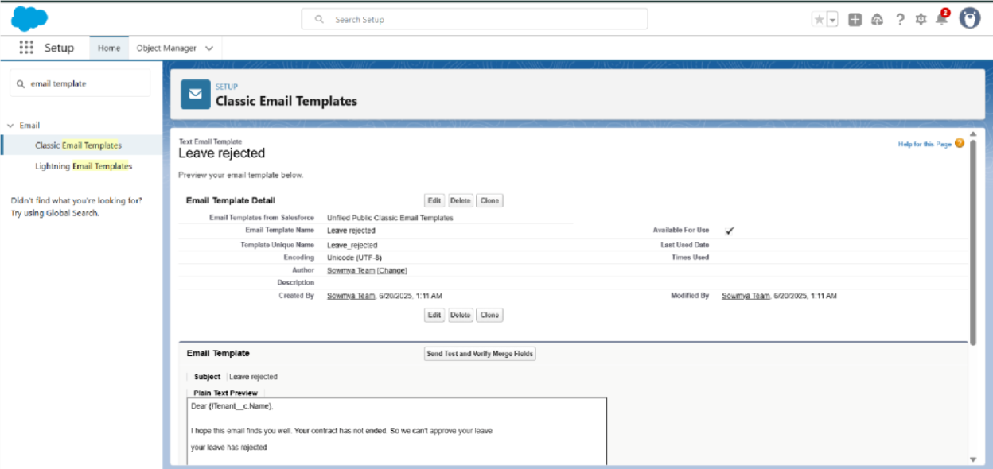

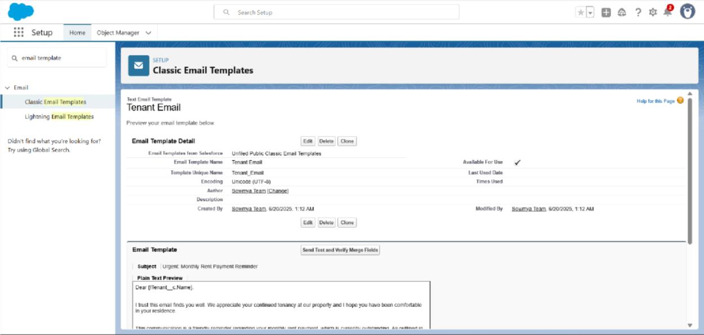

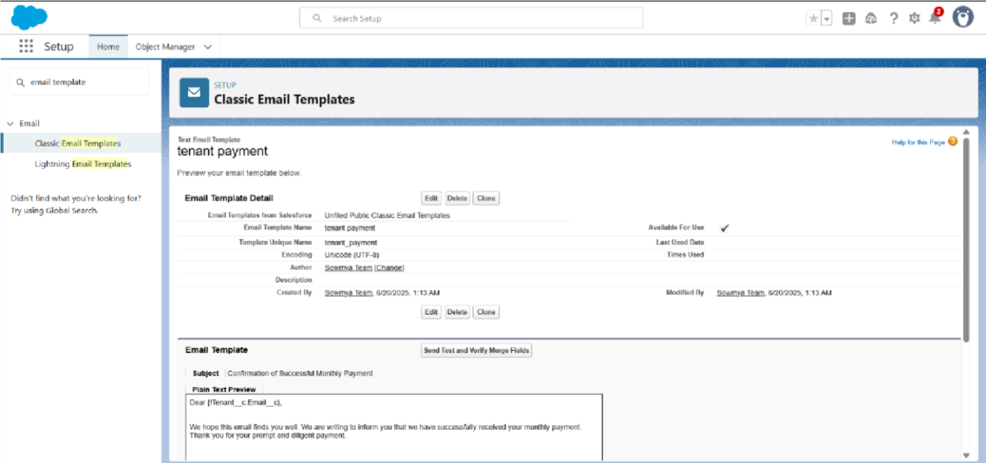

* Approval Process creation

For Tenant Leaving:

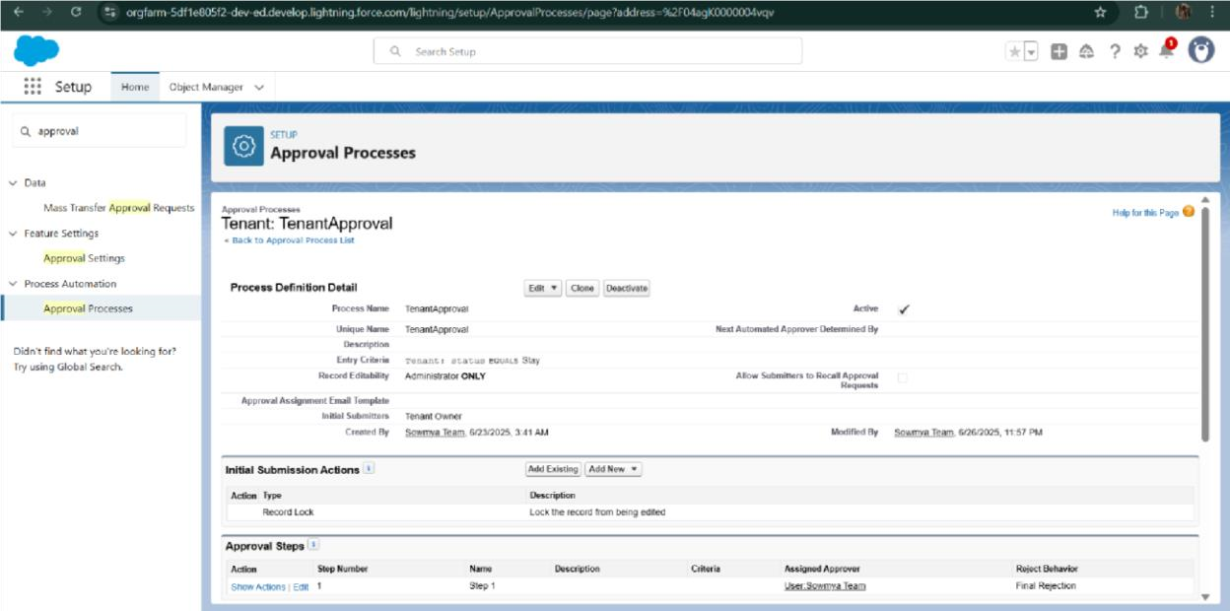

For Check for Vacant:

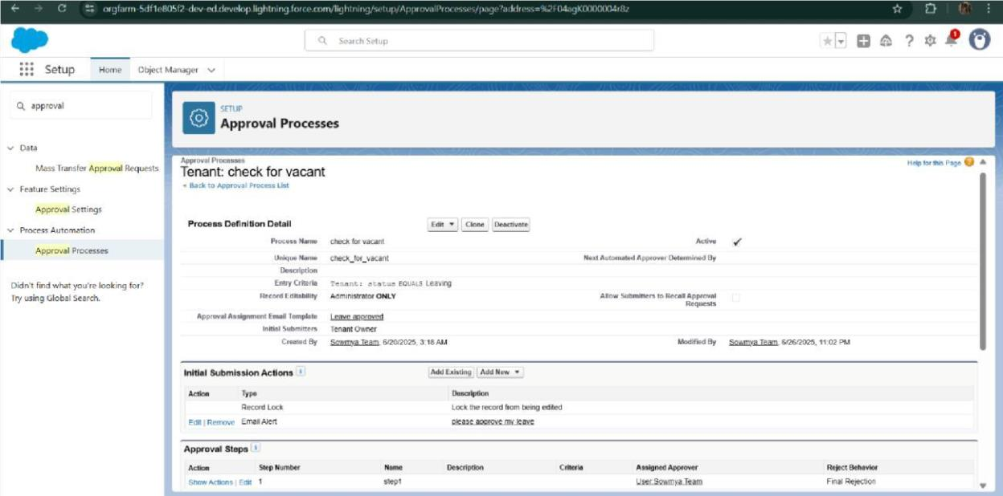

* Apex Trigger

Create an Apex Trigger

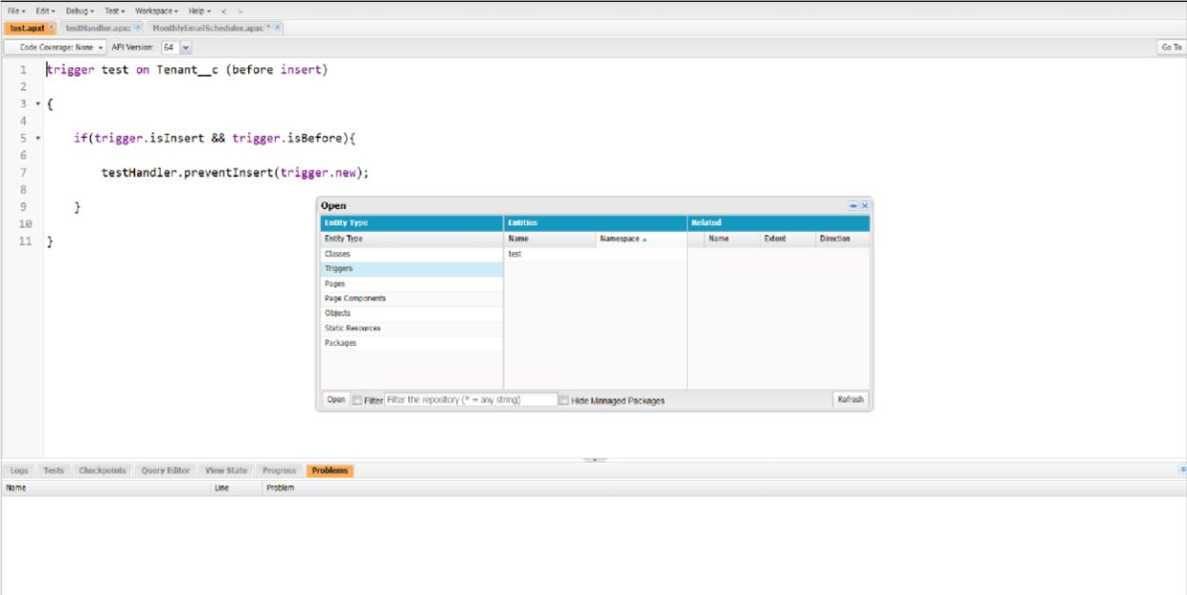

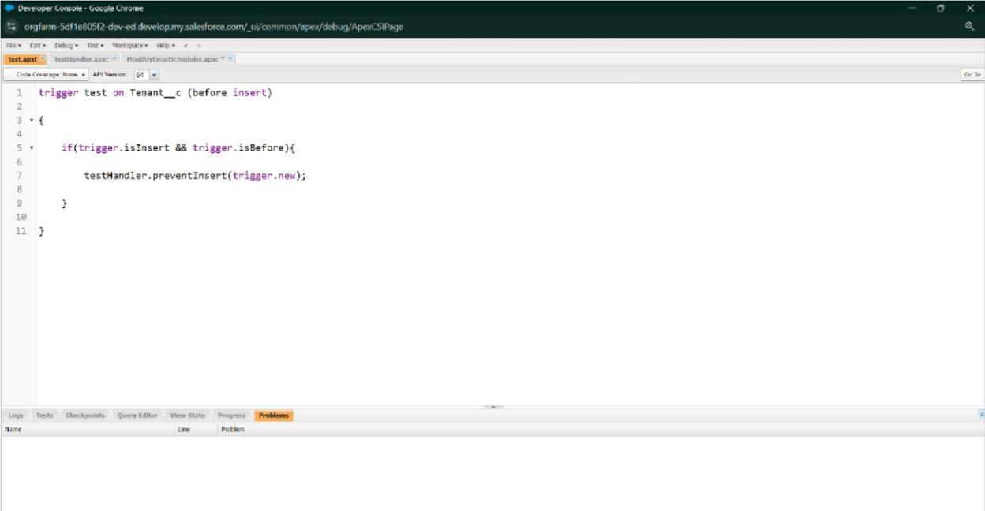

Create an Apex Handler class

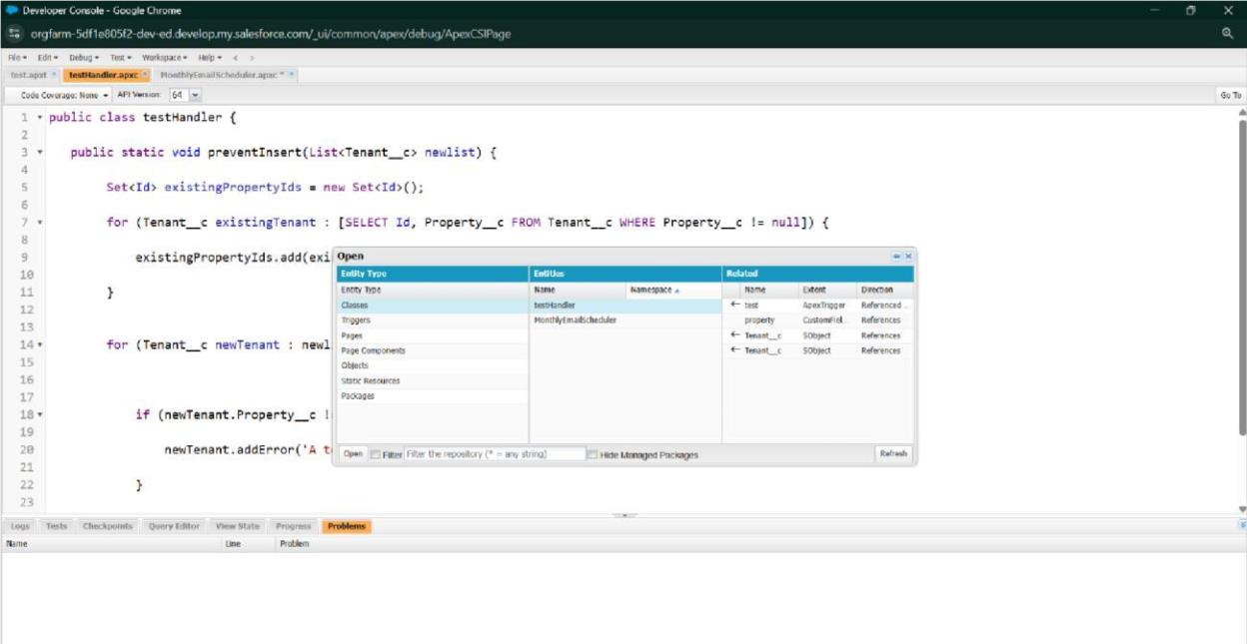

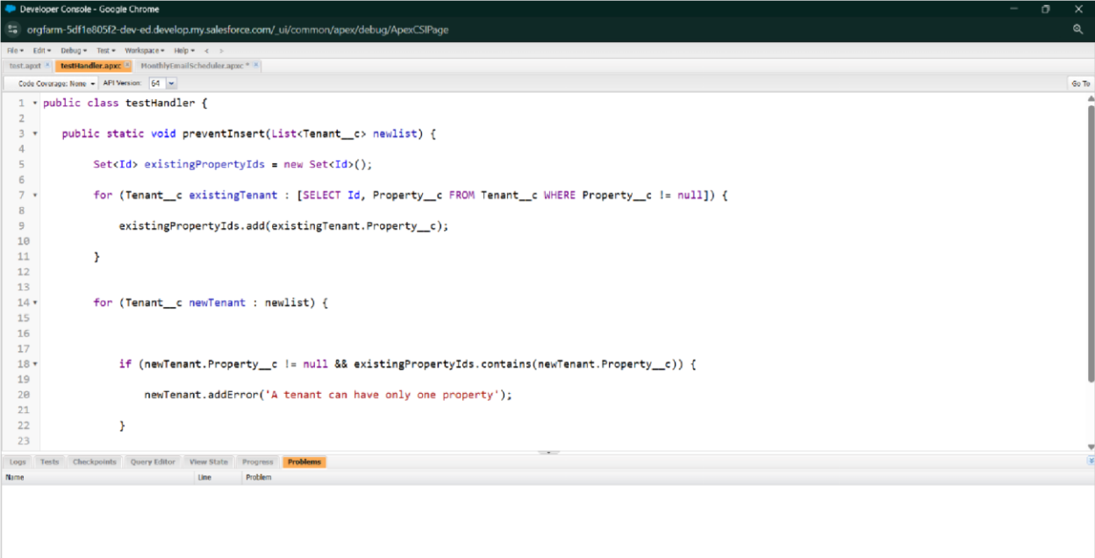

* FLOWS

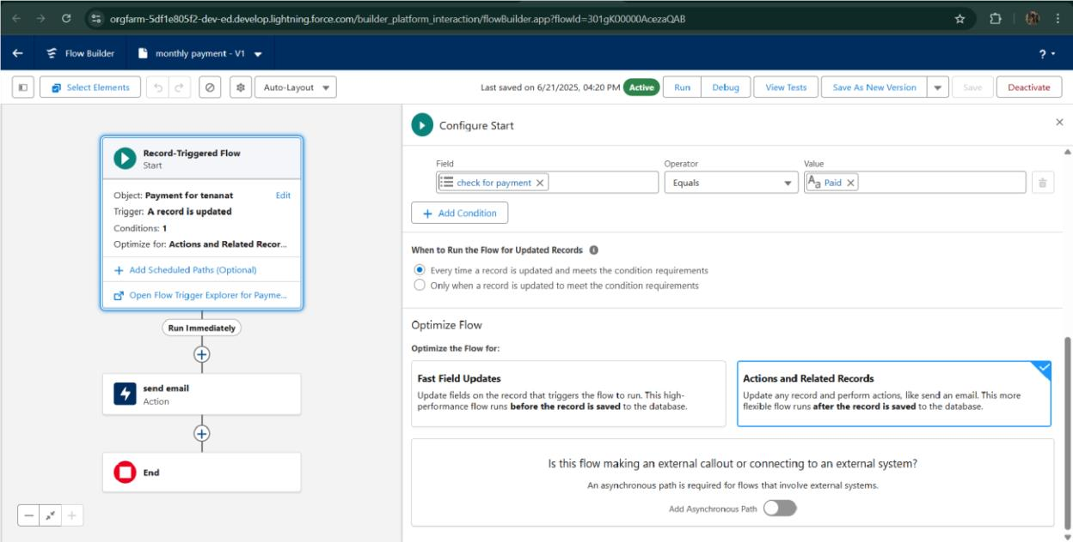

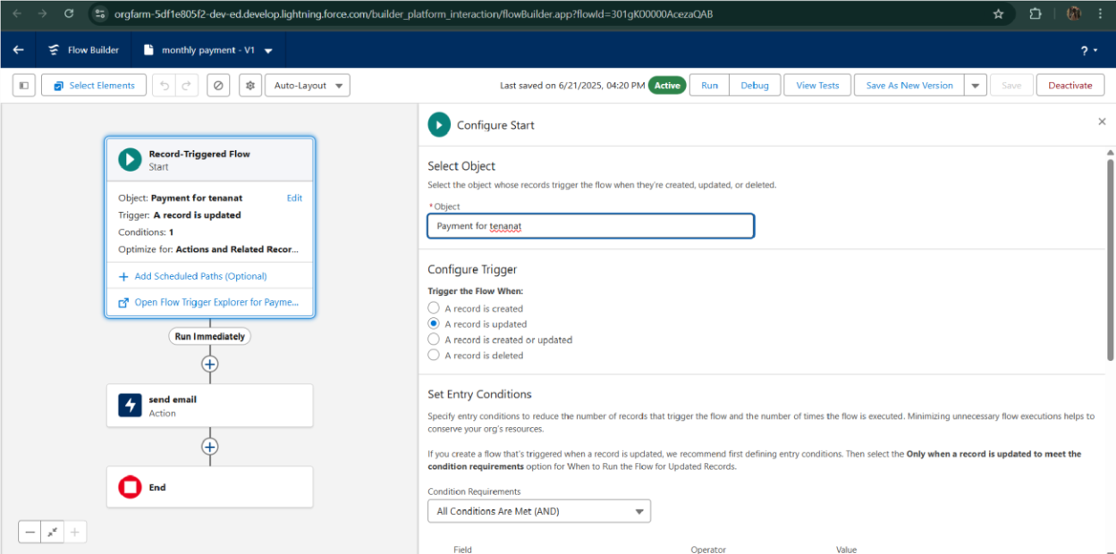

* Schedule class:

Create an Apex Class

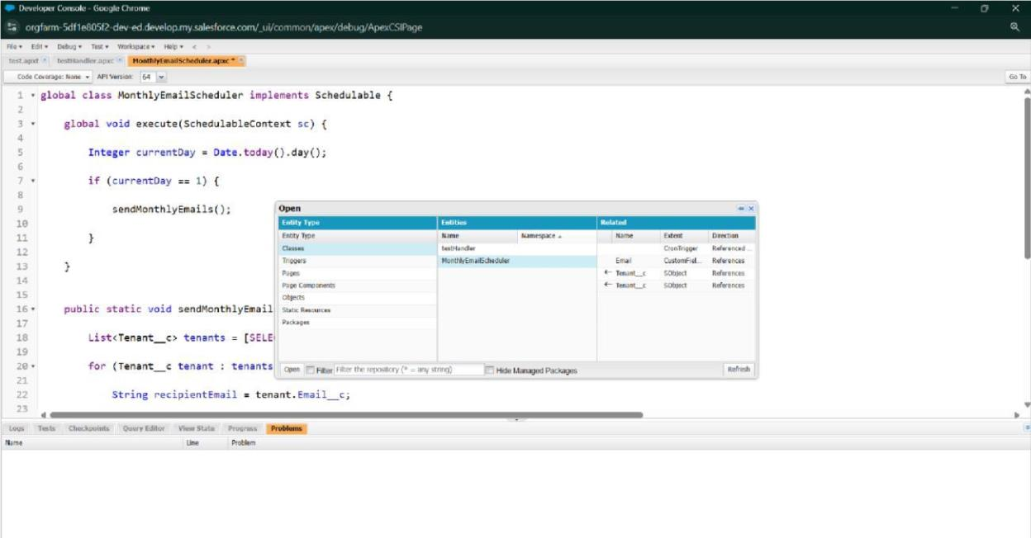

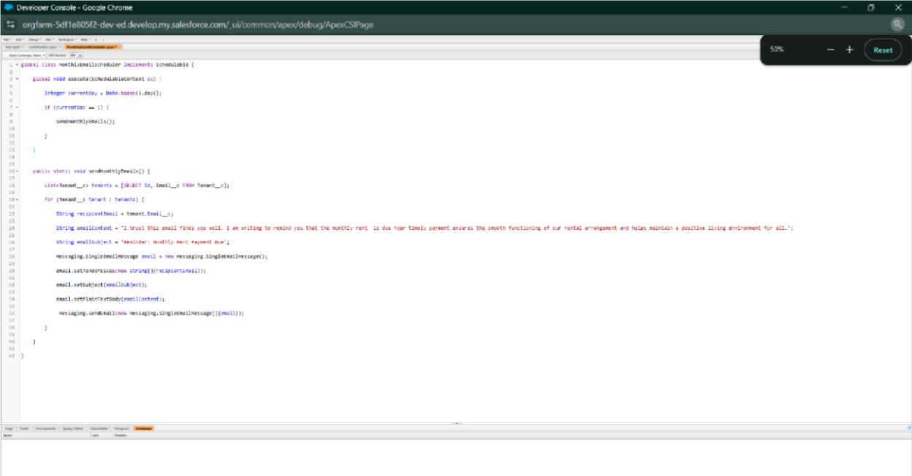

Schedule Apex class

